(Approx. 1754 words)

President's Corner
Tech Trials at Thirty-Six Thousand Feet
by Greg Skalka, President, Under the Computer Hood User Group
www.uchug.org
president (at) uchug.org

I'm writing this in a big metal tube speeding through the sky. We are finally on vacation, our first of 2021. My wife and I have anticipated this trip through the pandemic regulations, vaccinations, reduced restrictions, and more normalcy to reinstated limitations due to virus variants and insufficient inoculation. We are repeating our vacation of a year ago in Idaho to visit friends and stay in their family cabin.

In 2020, we finally had the opportunity to take them up on their longstanding offer to visit Idaho when the pandemic canceled our other travel plans. It was one of the best vacations we've had. Last year, my wife was afraid to fly (no vaccines yet), so we drove from San Diego. It added four days to our trip but allowed us to see parts of the country we'd never visited before. We were concerned about the reliability of my wife's SUV, so we rented one for the trip. This proved to be fortunate, as her car's transmission failed the day after we returned (thankfully a warranty replacement). A year ago, most people were locked down, few were traveling, so rental cars were inexpensive and available.

This spring, people were getting vaccinated and starting to travel again, so rental cars were in short supply and very expensive (3x what we paid last year). Even though still under warranty, I don't trust my wife's car, so we booked plane tickets to Boise (which were very reasonable). We didn't need a car there anyway; our rental last year sat parked under the trees by the cabin the entire visit.

About a week ago, I started preparing for our ten-day time away. First, I needed to tune up my technology to take with me and leave behind. Next, I'd need to collect and organize all the cameras, computers, and gadgets I wanted to take with me, along with all the batteries, chargers, and accessories that go along with them. I also wanted to go through my smart home and security devices to verify everything was working correctly. I want to make sure my home is secure and looks occupied while we are away. I also wanted to trade out backup drives just before we depart; my son allows me to store an encrypted USB hard drive at his home in Escondido as an off-site backup.

I recently had a few issues with some smart home devices, so I started with those. I have several light controllers from three vendors - smart bulbs, smart plugs, and smart switches. Each requires a separate app on my phone, but our Alexa smart speaker can also control all. I use these daily (programmed) to keep me from falling down the stairs during workdays’ dark mornings. I also have light sequences that can be enabled to make it look like we are home when on vacation. These are light systems consisting of the device and the app. Some are more robust than others, but none are 100% reliable, so that's why I have kept three sources.

I think the most reliable is the Belkin Wemo system; I have most of their devices. In addition, I have one smart bulb from TP-Link (uses the Kasa app) and several smart bulbs from Feit Electric (sold at Costco). I easily verified all my Wemo devices through its app, and it even offered to update the firmware in one device (easy and successful). I have some additional sequences set up in the app to turn lights on and off in the evening randomly, so I made sure they still made sense. I was able to do the same with my one Kasa app device.

When I tried to check the Feit devices through their app, I ran into a roadblock. Unlike the others, it wanted me to log in. It asked for a username and password, but my notes from the installation a year ago had no username, only a password. I tried my email as the username, but it wanted to set up an account. I finally tried my cell number as the username, which worked. This Feit app looks like it was coded on a very small budget.

In playing with the email account setup, I had started to initialize one of my existing smart bulbs but could not complete its setup successfully. I tried to complete the programming with the correct phone number account, but the bulb seemed to flash an error code. I had a spare Feit smart bulb and confirmed it was OK (and I did not have an app problem), but I also found the Feit app was so cheap that they left off a way to delete a device. I concluded the original Feit smart bulb was "bricked." I decided to install a Wemo smart plug for that lamp with a "dumb" bulb and that set up easily. I think I'll consider avoiding other Feit smart products and use Belkin Wemo, which has a much better app.

I also have several smart security camera types that I like better than the others. My current favorite is from Blink (owned by Amazon); I have six of their cameras. I have four that run on a reported 2-year battery, so they are easy to install (no wires at all). To preserve battery life, I avoid streaming video and instead take snapshots. These cameras seem very reliable. I also have two Ring cameras (Amazon also owns Ring). These cameras have internal batteries, but I have to charge them every few months. I am less thrilled by these, primarily due to app and unreliable access issues. I also have three older Samsung cameras that work pretty well but sometimes have their issues. Between all of these, I think I have pretty good camera coverage.

I'm traveling with a large assortment of tech gear in the backpack under the airline seat in front of me. In addition to the usual smartphone, cameras, and GPS receiver (and all their batteries and charging gear), I'm not traveling with a Chromebook for the first time in many years. The HP 14" Windows 10 laptop that became my primary computer when my desktop "chameleon" computer became unpredictable a couple of months ago seemed like my best choice to take. It is not too much bigger than my Chromebook, boots surprisingly fast, and is much more powerful (i7 processor). I did have to do some prep work to prepare it for travel. I finally installed Thunderbird and transferred the email flag from my old Fujitsu laptop to this one. It took some research (I had to learn about Thunderbird profiles), but I got my account and all my stored emails transferred over in an evening.

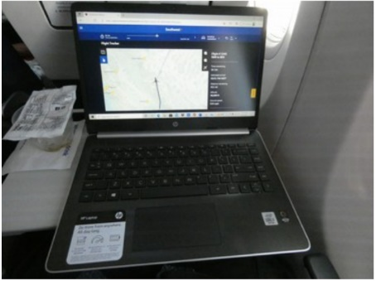
I also found out something rude about Microsoft Word. I planned to write the majority of this column on the two in-flight intervals I would have on this trip, as I'd be too busy before and during the trip, and the newsletter deadline is the day I would return. I wrote a couple of paragraphs on the Windows XP computer I usually write on and then transferred the Word ".doc" file to my laptop. Fortunately, I decided to open the file in Word, which was a good thing. Unfortunately, the Office 2016 version on the laptop refused to open the older (Word 6.0, from 1993) document in anything but Protected Mode, which meant no editing. Since I couldn't figure out how to defeat this nanny-program restriction, I took the file to my Fujitsu laptop (hosting an intermediate Office version) and saved the file as ".docx," which I could then edit on the HP laptop. There must be a way to fix this, but I couldn't find it quickly. How rude.

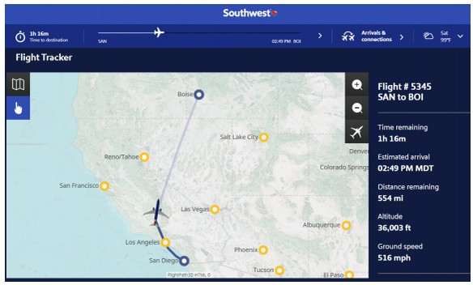
This is the first flight I've been on in two years. It is odd to be jammed together with all these masked people. Travel on Southwest Airlines seems the same. I connected my laptop to their Wi-Fi on the plane to view their flight tracker. They provide free text messaging (requires iMessage or WhatsApp; no thanks, though), which is new. Also, they offer a bunch of decent free movies and free TV. I watched a bit of the beginning of "News of the World," a movie I'd like to see, which was just enough to verify that the earbuds I brought worked but were not the noise-canceling headphones that I guess would be required to have the experience be enjoyable. Besides, I had to get back to writing.
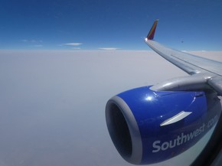
I sat by a window (I prefer to see out and like to take photos while in the air), which gave me a good view of all the smoke and haze in the air above our country from big wildfires in Northern California and Oregon. We are crossing over the southeast corner of Oregon, and it looks like a thick tan marine layer down there, with no surface features visible. The only things visible are a few high clouds above the haze. So sad. I hope the engines don't have problems with the dirty air.

We are now on the plane on our return flight home. We had a great time with our friends at their cabin, riding off-road vehicles, felling trees, kayaking, rafting, and watching the salmon coming up the river to spawn. I saw a lot more deer than I did last year, but no bear or fox and no moose like I was hoping to see. The cabin is off the grid, with solar panels, batteries and a generator for power, propane for cooking and heat, and a phone line and DSL internet. There is no cell coverage nearby, so smartphones don't do much when not connected to the cabin's limited Wi-Fi. Even then, I could not send photo SMS messages with my Android, only plain text. Email and little browsing were possible with my laptop.

All the technology I brought held up. Though the vacation is effectively over, many tasks in its aftermath remain. I have 16.5 GB of action cam video files and around 1500 photos to sort through and organize. I'll probably do what I did last year, organizing the videos and the photos from our two cameras and two smartphones chronologically per day. We know only our son has been in our house from the cameras we left in our home.

Time to start planning our next vacation!

